for testing!

I used mocha supertest to test the most of the function.

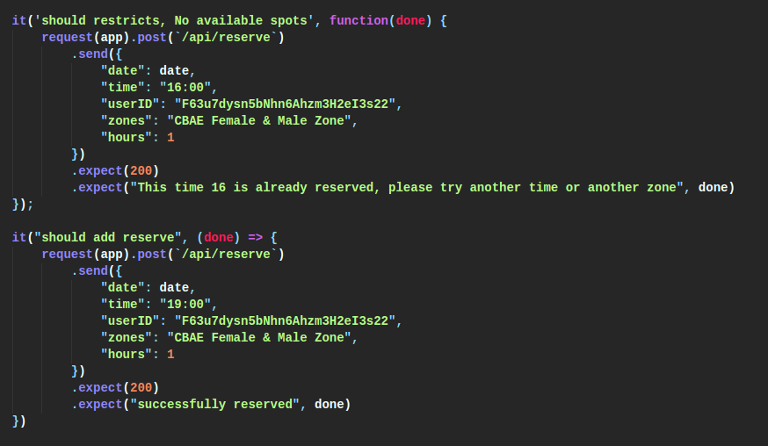

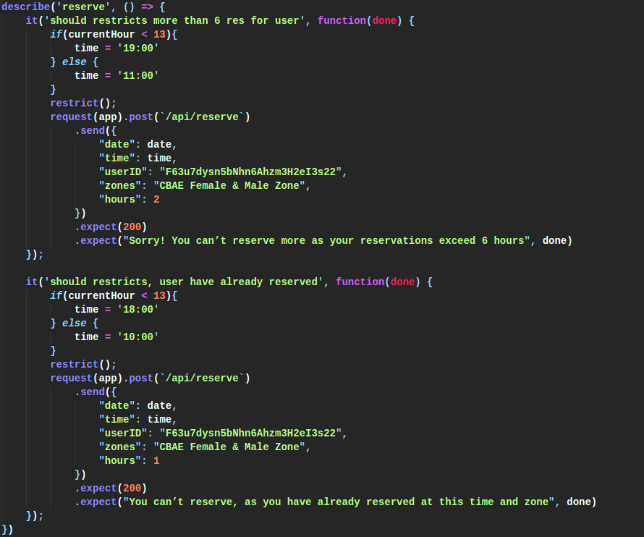

Before each test, I create like a scenario for it. So that It can work as if we are working on real. For example:

If I want the function to make test that the app will refuse to reserve if this spot at this time is reserved 4 times, I create a 4 reservations at this time before the test and then try to test.

Also I delete the reservations before adding the scenario, so no one will interfere with the other.